Part 3 Deliverable
Submit a folder or GitHub repository named capstone_part3 containing:
- All ML models, notebooks, and scripts.
- MLflow logs.
- Your deployment simulation.
- Your recommendation engine.
- A final capstone report covering methodology and findings across every task.
- A bias and fairness report.
- A README explaining your project structure and how to run it, and stating clearly whether you sourced a real accident dataset or used a documented proxy.

Task 1: Supervised Machine Learning Models
Build two supervised machine learning models using the traffic volume dataset. Both models should use a common, well-engineered feature set that includes:
Compare the models using the following appropriate evaluation metrics:
- Regression: MAE and R-squared
- Classification: Accuracy, precision, recall, F1-score and ROC AUC
Regression models
 | Linear regression | Random forest regressor
MAE | 814.47 | 274.22
R squared | 0.72 | 0.94
Linear Regression
- MAE = 814.47: Predictions differ from actual traffic volume by an average of approximately 814.47.
- R² = 0.72: The model explains 72% of the variation in traffic volume. While this is a reasonable baseline, the model may struggle to capture complex, nonlinear relationships in traffic data.
Random Forest Regressor
- MAE = 274.22: Predictions differ from actual traffic volume by an average of approximately 274.22
- R² = 0.94: The model explains 94% of the variation in traffic volume, indicating a strong fit on the test dataset.
Random Forest can capture nonlinear relationships and interactions between features, which may explain its stronger performance.
Classification models
 | Logistic regression | SVM
Accuracy | 0.99 | 0.99
Precision | 0.94 | 0.96
Recall | 0.95 | 0.97
F1 score | 0.95 | 0.96
ROC AUC | 0.94 | 0.96
- Accuracy (0.99 for both): Both models correctly classify approximately 99% of the test samples. However, accuracy alone may not reveal differences in performance on minority classes.
- Precision (0.94 vs. 0.96): SVM is more reliable when predicting the positive class, producing fewer false positives relative to its positive predictions.
- Recall (0.95 vs. 0.97): SVM identifies a higher proportion of actual positive cases, resulting in fewer false negatives.
- F1 score (0.95 vs. 0.96): SVM has a slightly better balance between precision and recall.
- ROC AUC (0.94 vs. 0.96): SVM demonstrates better ability to distinguish between positive and negative cases across classification thresholds.
I would recommend SVM, based on the results you provided.
- It has higher precision, recall, F1 score, and ROC AUC.
- It offers slightly better classification performance while maintaining the same reported accuracy as Logistic Regression.
- Logistic Regression remains a useful alternative if interpretability and explaining how features relate to predictions are important.
One caution: an accuracy of 0.99 is excellent, but check for data leakage, class imbalance, and whether both models were evaluated on the same unseen test set. If the scores are unexpectedly high, these checks are especially important.

Task 2: Unsupervised Machine Learning
K means clustering
K-means clustering was performed using features such as weather condition, temperature, hour of the day, traffic volume, holiday status, and weekday/weekend status. The Within-Cluster Sum of Squares (WCSS) method was used to determine the optimal number of clusters, with three clusters identified as the most suitable choice.
Following the clustering process, several visualisations were generated to examine the distribution and characteristics of each cluster. The results suggest that traffic volume and time of day are the primary factors influencing the three clusters. In particular, the plots of hour and traffic volume reveal relatively distinct patterns, indicating that the clusters are strongly associated with different levels of traffic volume at specific times of the day.
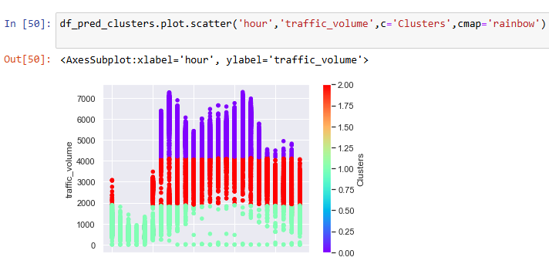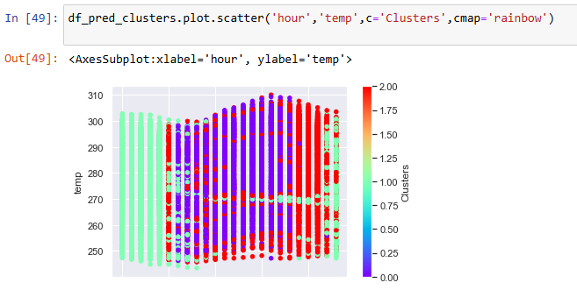
- Cluster 0 – Low traffic volume: This cluster is characterised by traffic volume below approximately 2,000, predominantly between 6 a.m. and 6 p.m.
- Cluster 1 – Moderate traffic volume: This cluster is associated with traffic volumes ranging from approximately 2,000 to 4,000, primarily between 11 p.m. and 5 a.m.
- Cluster 2 – High traffic volume: This cluster is characterised by traffic volumes exceeding approximately 4,000, occurring mainly around 5 a.m. and between 7 p.m. and 11 p.m.
In contrast, temperature and weather conditions appear to exhibit greater overlap across the three clusters, suggesting that these features may be less effective at distinguishing cluster membership in the visualisations examined. Overall, the clustering results indicate that traffic volume, together with the time of day, plays a more prominent role in differentiating the identified clusters than temperature and weather conditions.

Association rule mining
Association rule mining was conducted using the Apriori algorithm to identify relationships between time of day, weekday type and weather, congestion level The resulting rules were ranked by lift to identify conditions associated with congestion more strongly than the overall baseline. Support was used to assess how frequently each pattern occurred, while confidence measured the proportion of observations satisfying the antecedent that also satisfied the consequent. The highest-lift rules were interpreted to identify recurring traffic patterns.
Rule | Support | Confidence | Lift
Weekday + Morning Rush → High + Mist | 2.07% | 16.95% | 4.65
Morning Rush → High + Mist + Weekday | 2.07% | 12.07% | 3.48
Weekend + Night → Low + Clear | 2.53% | 34.86% | 3.34
Morning Rush → High + Mist | 2.07% | 12.08% | 3.31
Weekend → Low + Morning Rush | 3.01% | 10.60% | 3.22
Rule 1: Weekday + Morning Rush → High + Mist
Interpretation: Approximately 2.07% of all observations involve weekday morning rush hours together with mist and high congestion. Among observations during weekday morning rush hours, 16.95% contain both mist and high congestion.
The lift of 4.65 indicates that the combined outcome of high congestion and mist occurs about 4.65 times as often when the conditions are weekday morning rush hours as it does overall.
What it means: Weekday morning rush hours are strongly associated with the combination of misty weather and high congestion. However, the confidence is relatively low, so this combination does not occur in most weekday morning rush-hour observations.
Rule 2: Morning Rush → High + Mist + Weekday
Interpretation: About 2.07% of all observations satisfy all four conditions: morning rush hour, weekday, mist, and high congestion. Among all morning rush-hour observations, 12.07% contain the other three conditions together.
The lift of 3.48 means this combined outcome is approximately 3.48 times as frequent during morning rush hours as its overall baseline frequency.
What it means: Morning rush hours are associated with the combined pattern of weekdays, mist, and high congestion. This is similar to Rule 1, but this rule 2 contains only morning rush hour.
Rule 3: Weekend + Night → Low + Clear
Interpretation: Approximately 2.53% of all observations occur at night on weekends with clear weather and low congestion. Among weekend nighttime observations, 34.86% have both clear weather and low congestion.
The lift of 3.34 means this combined outcome occurs about 3.34 times as often under weekend nighttime conditions as it does overall.
What it means: Weekend nights are associated with clear weather and low traffic volume. This may reflect lighter travel demand during those periods, although the rule alone cannot establish why the pattern occurs.
Overall findings
Morning rush-hour pattern: Weekday morning rush hours are strongly associated with the combination of misty weather and high congestion. However, the low confidence values indicate that this combination occurs in only a minority of morning rush-hour observations.
Weekend nighttime pattern: Weekend nights are associated with low congestion and clear weather, suggesting a recurring pattern of lighter traffic during those periods.

These are associations, not evidence that mist causes congestion or that clear weather causes traffic to decrease. Also, rules with similar antecedents and overlapping outcomes are not independent findings.

Task 3: Deep Learning with Explainability
ANN Traffic Volume Prediction
An ANN was implemented to predict traffic volume. Training was tested with 100, 200, and 400 epochs, achieving MAE values of approximately 600+, 400+, and 380+, respectively. The final model was set to 200 epochs as doubling the training duration yielded only a modest improvement in MAE.
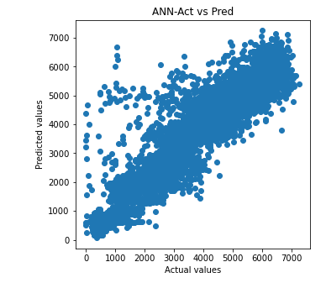
SHAP Explainability Analysis
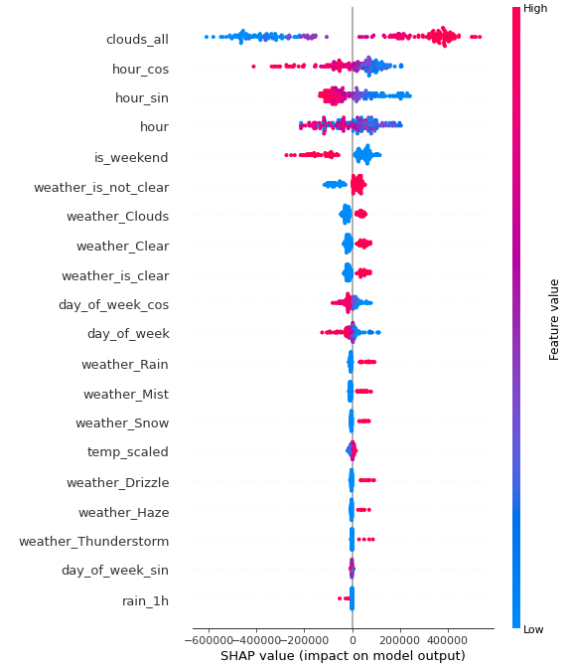
SHAP analysis identified clouds_all as the most influential feature, followed by hour_cos, hour_sin, hour, and is_weekend.
Cloud coverage (clouds_all) was the dominant feature, with a substantially higher SHAP importance than the other variables. This indicates that cloud coverage had the greatest influence on the model's predictions.
Time-related features (hour, hour_sin, and hour_cos) were also highly influential, suggesting that the model learned temporal patterns in traffic volume. Traffic conditions can vary throughout the day due to commuting and peak-hour demand. The sine and cosine transformations represent the cyclical nature of time, accounting for the continuity between late-night and early-morning hours.
Weekend indicator (is_weekend) ranked among the top five features, suggesting that the model identified differences between weekday and weekend traffic patterns. These differences may reflect variations in commuting behaviour, work schedules, and leisure travel.
Other weather-related features, including weather_Clear, weather_Clouds, and weather_is_not_clear, also contributed to the predictions, although their individual SHAP importance was lower than that of clouds_all. Features with negligible SHAP importance, such as holiday_flag, snow_1h, and weather_Smoke, contributed little measurable influence under the SHAP calculation used.
SHAP was used to improve model interpretability by identifying the features most influential in its predictions. However, feature importance indicates predictive associations rather than causation.

Task 4: Apply an Advanced AI Technique
Apply at least one advanced technique from the programme.
Choose one:
- Model quantisation
- GAN for synthetic traffic data
- Self-supervised anomaly detection
- MLflow for experiment tracking
Task 5: Build a Traffic Recommendation System
Transform the analysis and model outputs into a practical Route Recommendation System.
Because the dataset represents a single corridor, the system should focus on travel timing rather than route selection, unless you introduce additional route data.
The system should:
- Identify lower-traffic travel periods
- Consider day type and weather conditions where appropriate
- Recommend suitable travel windows
- Generate a plain-language recommendation
For example:
"For a weekday journey, consider travelling between 10:00 and 11:00 AM, when historical traffic volumes are typically lower."

Task 6: MLOps and Deployment Simulation
Unable to attempt this task in time
Task 7: Responsible and Sustainable AI
- Bias and fairness: Write a bias and fairness report covering, at a minimum:
- Any known sampling or coverage limitations in your data.
- Any proxy labels you used and the risks associated with them.
- How errors might be distributed unevenly across different conditions or time periods.
Sampling limitation is that this is only for one stretch of road. Traffic conditions are also affected by the surrounding roads.

A proxy was used for accident risk, derived from existing traffic and weather variables – using existing variables to predict this proxy label is then a bit less reliable and also much easier for the ML models to achieve high levels of accuracy.
Proxy label was used for congestion category, derived from traffic volume. When trying to predict for congestion category, I have always omitted traffic volume from the dataset.

Known issues being that I know a good number of datapoints is missing for 2014 and 2015. Coverage may not be representative across the days of the year. Similiarly, this is a relatively imbalanced dataset in terms of weather conditions. Some conditions like fog and smoke have significantly less occurrences than others like clear and cloudy. Perhaps boosting is a good area to pursue next in order to improve accuracy.
- Governance and sustainability: Include a short discussion of governance and sustainability in mobility AI. Consider:
- What oversight should be in place before a model is trusted for real-world decision-making.
- The environmental or resource trade-offs associated with your modelling choices.
Mobility is a sensitive area as it directly affects many humans, including those who did not use to utilise the AI solution whatever it may be. Oversight should ensure that local laws and regulations (such as traffic laws) are followed strictly as a bare minimum.
It is also key to ensure that there is a human layer before implementation, to ensure that accountability lies with a human review.
AI is known to consume a lot of environment resources at the moment, competing with human communities for limited essential resources such as energy and water. It is important to balance AI resource usage and accuracy in order to ensure prudent use of resources by AI.

